

**BANGLADESH UNIVERSITY OF ENGINEERING AND TECHNOLOGY**

**A REPORT ON**

**Term Project**

**Hospital Management System**

Course Name: CSE 108

Submitted to:

**Mohammad Saifur Rahman**

Assistant Professor, Dept. of CSE, BUET

**Ishtiyaque Ahmad**

Lecturer, Dept. of CSE, BUET

#### Siddhartha Shankar Das

Lecturer, Dept. of CSE, BUET

Prepared by:  
Sanjay Malakar

Roll : 1505057

Section : A

Date of submission: 22.12.2016

**Server :**

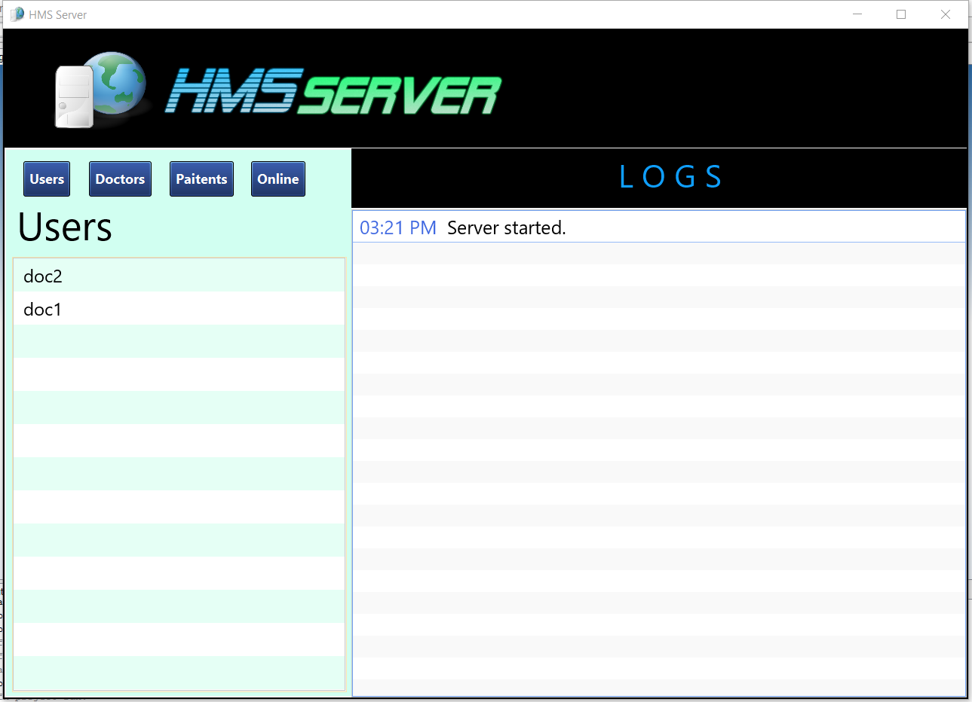

**The server stores all the data and the logs.**

**Login :**

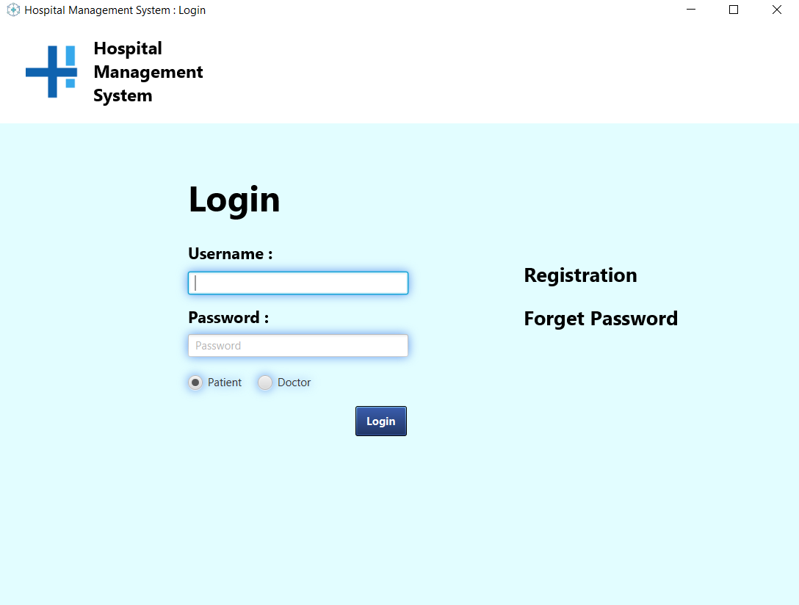

**Users login through this form to the server.**

**Registration :**

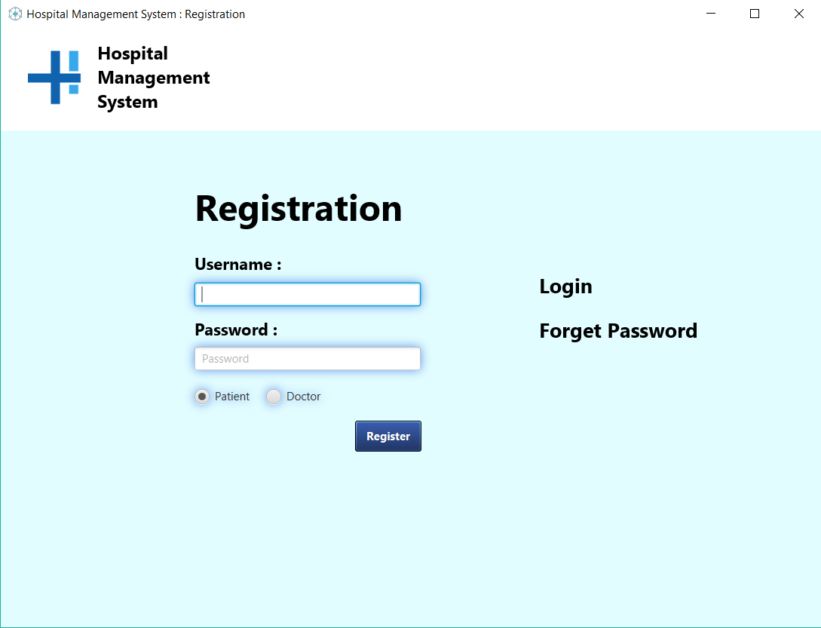

**To create new accounts.**

**Registration form :**

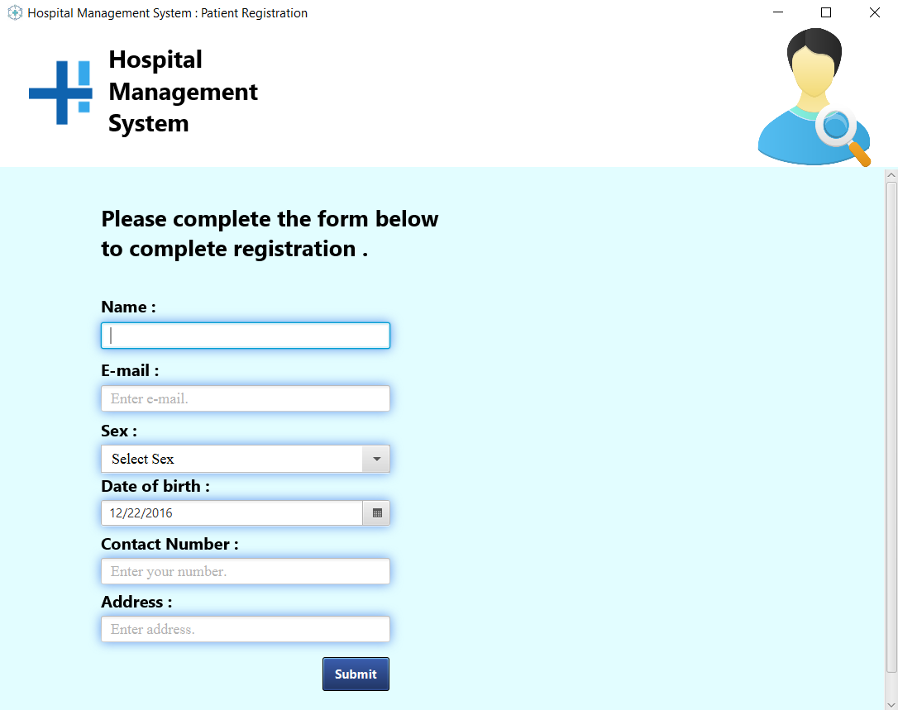

**UI :**

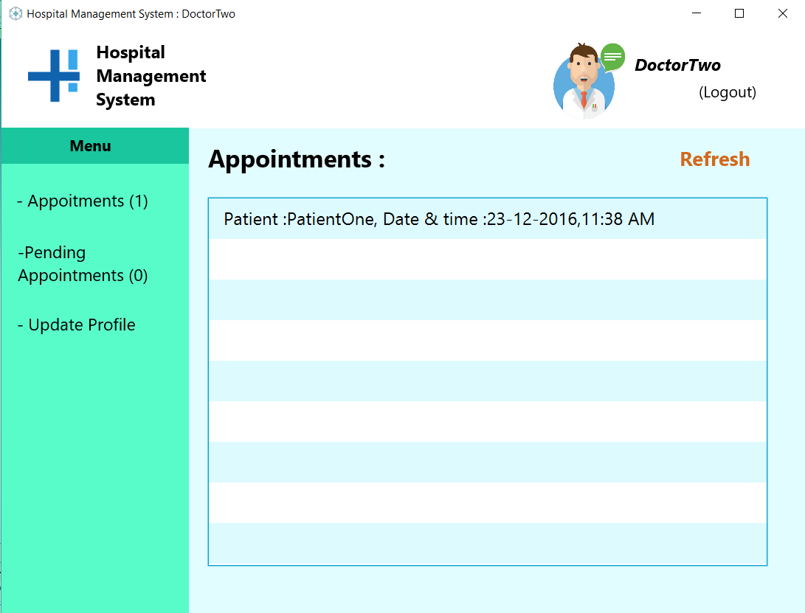

**Taking appointments :**

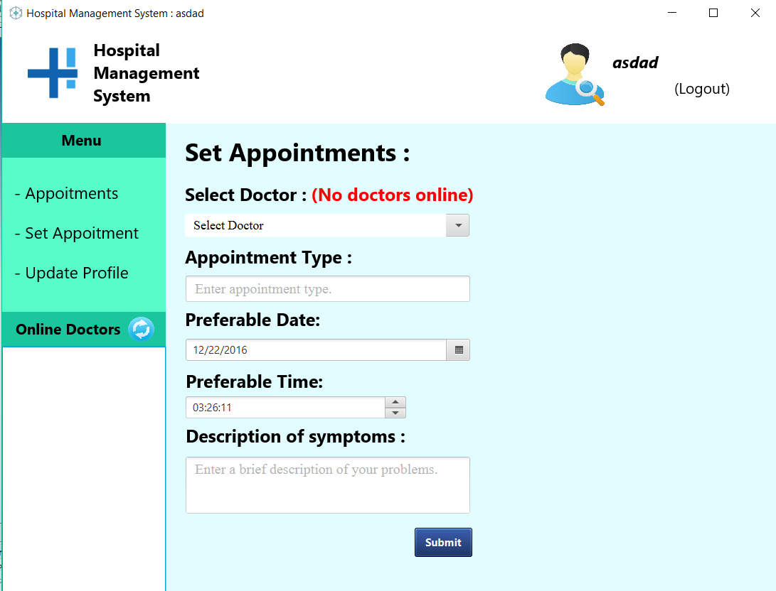

**Drive link :**

**https://drive.google.com/file/d/0ByZ6wLj2y_piRjdOUmxlcEh1SUU/view?usp=sharing**